By Ana Ferreira based on an interview with Satya Kaur
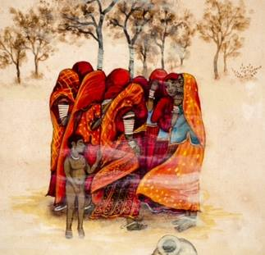

Satya explained the phenomenon called "The Global Red Tent Movement" which has been gaining momentum recently. It arose after the publication of the book "The Red Tent" by Anita Diamant - a novel based on the biblical records of Abraham's tribe from the perspective of a woman.
This best-seller author made the concept of the Red Tent known. Currently there are, however, several other visionary women who have spurred this movement onwards and who have succeeded in making it known covers in most the countries, especially in the West.
Dr Isadora Leidenfrost, DeAnna L'am, Alicia Starkweather, are some of the activists who stand out and who have disseminate a lot of information over the Internet, and beyond. There is even Red Tent TV Channel!
At this time of diffusion, most red tents are periodic spaces but the aim is to ensure a one is permanently available in every neighborhood in our lifetime.
This is because all women menstruate and need a place and time to retreat and take greater care of themselves.
This is something that is still not recognized by our society. We have to regain the honor of this periodicity, the need to rest and be privileged at this time. It is also a time of the month in which a woman's physique is weaker whilst her mind is more attuned to the spiritual dimension. Unknowingly she becomes more ineffective on the social and rational level yet more open and strong in the psycho-spiritual field.
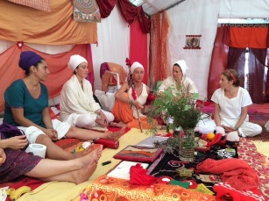
It is important that the Red Tent is recognized as a collective space where women share, nourish and enrich each other in terms of knowledge at all levels. All women worldwide are subject to this altered state and all should be entitled to such regular check-ins. Our patriarchal heritage, however, has boycotted this very old tradition and indeed the impact on our society will be huge. It will implies that women will place their own nature first instead of their husbands', children's, parents', jobs', pets'. Such a priority, in itself, is a radical change in our collective and social consciousness. In a collective space where there’s intimate sharing of what is happening in their lives, women become stronger. Divided women are easier to manipulate than if they join regularly with others knowing they have companions always by their side. None would ever be subject to abuse or exploitation.
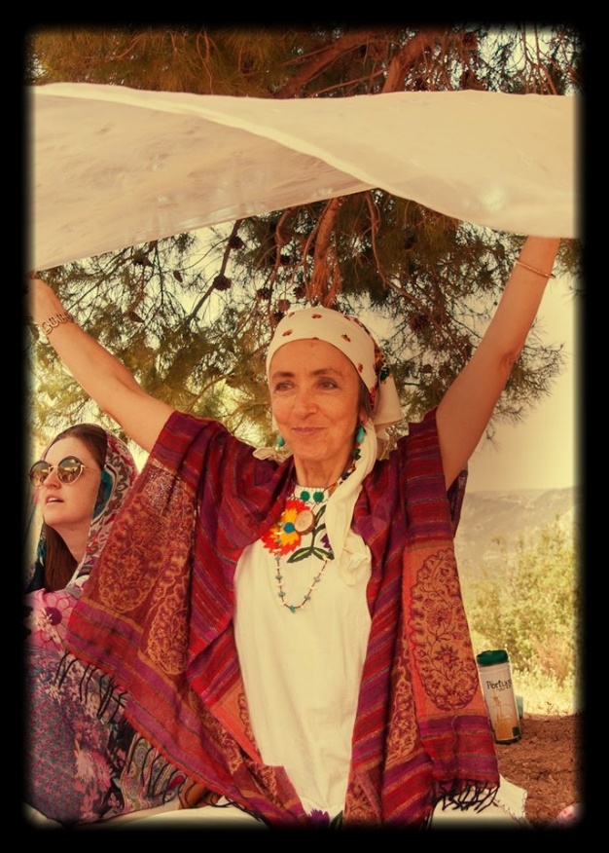
For most people, menstruation is seen as an inconvenience, something dirty: we have been programmed to view it like that. We can’t yet see the menstrual blood as the nest of mankind where our lives grew, most pure and precious.
To oppose all the negativity that has been accumulated over generations and millennia, we need to create a very positive image of menstruation and femininity alongside a realistic approach. In our society, women hide the fact they menstruate, as if nothing happens. This is to deny a fact that needs different treatment for, when we bleed from any other part of the body, we take it as a warning and we stop what we are doing. Bleeding means there is an opening, an internal organ needs to be taken care of and our energy is leaking which needs to be contained and we need to be protected.
It is important to prepare girls for the auspicious day when they will menstruate. Celebration as an initiation ritual sends a positive message and is a pre-cursor of future pleasures.
Some activists have re-introduced ways to celebrate the first menarche with gifts, party announcements, the sharing of secrets related to sexuality, because until then the child's innocence has to be preserved. In some cultures, such as Mexico and Sri Lanka, such rites were never abandoned.
Thereafter girls can enter the Red Tent and catch up with their elders and dreams of fulfillment as women. As we proceed in life, the Red Tent becomes an important means of releasing problems that accumulate during the rest of the month.
It offers other opportunities such as a time to learn, share, pamper and it can be used for any other kind of activities such as meditation, prayer, sleep, talk, listen, play or the arts, i.e. whatever the participants decide to do.
The Red Tent is a safe and cozy space for women to open and share what many currently carry alone in the form of a conscious or subconscious burden. Past experiences or traumas, fears which could die with or could affect future generations all come to the surface and it is reassuring to note that many other women have and do go through the same. Taboos are broken feelings heard. Giving and receiving is reciprocated in turns. There is no hierarchy, women sit in a circle and anyone may propose or express what they need.
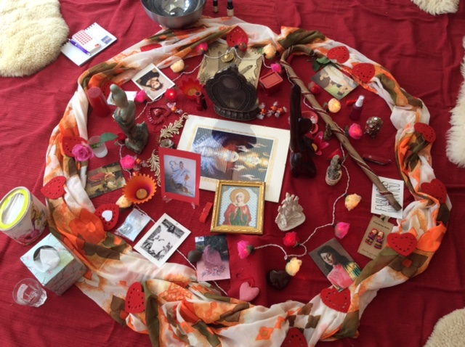

There are other spaces with similar functions known as Moon Lodge or Temple of the Moon, where women meet once a month as a council authority. Women together, under such auspices can issue mandates in relation to what is happening in the world. Collectively they propose anything that may influence the world, as least locally. Such are, not only place to be together, but also to create collective decisions with a degree of legal weight. If, for example, a red tent decides something which other tents choose to adopt, the domino impact can be enormous. Women are, after all, half the population of the world!
The impact is still hard to conceive or predict because we are at an early stage but is already very fast and is spreading everywhere. It is transforming the lives of each and all. It is just a matter of time before this transformation spreads spreads through families and social networks. It will be beneficial because decisions can be taken and the denials assumed, for example, buying certain products, go to work on days when we are menstruating. Petitions social and political level up.
Red Tents are not insignificant and silent, quite the contrary, they encourage women to take on more power and responsibility.
There will be changes in labor law in due course. These will affect both genders beneficially since roles within the family and at work are interchangeable. Women have, in the past, taken revenge by seizing up family dynamics and control over the house. As they assume other responsibilities and privileges outside of the home, including attending the red tent, sometimes for days, they will temporarily abdicate from some duties. This induces community sharing of tasks previously concentrated on one person. The whole structure of society will be altered to become more community based.
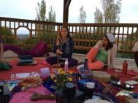
We urgently experience isolation in our homes, households, whereby more sharing will prove beneficial. With more time, power, freedom, we are encouraged to take control. We have become more than just mothers, wives, employees, but individuals who make decisions.
This may be innovative for many women who feel comfort in assuming that everything depends on them. Such is a reality created by us, making us indispensable which we will have to relinquish. It is not only a prison but also a very large load.
Men everywhere are already assuming their female part which was denied to them by society. They will now call on their most sensitive and intuitive part which thus far did not fit with the image of "macho" under which they were raised.
These are radical changes already somewhat operational in our society under a time when the consciousness of humanity is changing. The Age of Pisces lasted until around 2012 and we have entered the Age of Aquarius in which there is a different consciousness on all levels. There is a review of all the molds of society and we have to keep up the change.
The introduction of the Red Tent is a preparation for a different consciousness of future society, the role of each gender, the education of children, etc. We have to adapt ourselves and claim our happiness since we, women, are the agents of change. We incarnated at this time in history because we are ready to participate in this transformation.
How to create a Red Tent?
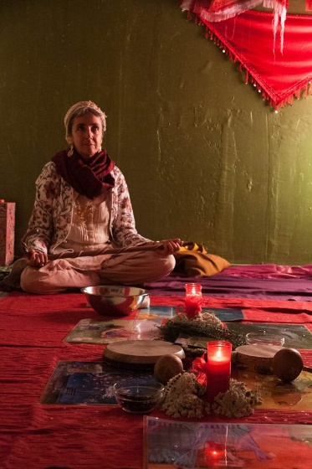
No special qualification for this is needed. It is simple and our willingness to support other women is innate in us. There are certain guidelines which we can follow, specially the sensitivity with which we communicate. We can find a space in our neighborhood. You may want to call on someone who is accustomed to or experienced in setting up Red Tents and adopt a similar model adapted to the needs of the local residents.

Is it safe?
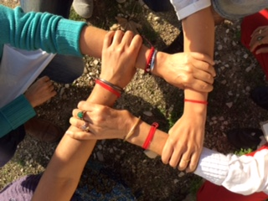
Indeed we may not feel safe in an all-women setting since we may have not be accustomed to solidarity amongst women. Red Tents are private spaces where what happens is not disclosed and names are not mentioned in another context. What happens there is not subject to confidentiality.
Women sit in a circle and pass and hold a stick in order to speak. This gives each the opportunity and right to speak and listen so that this happens in a fair way. No one dominates the space unless there has an urgent need for someone who may be in need of receiving more time. What goes on in the tent is at once secret and sacred. Each community, according to its members, decides on how their Tent is run. Attendance is, of course, always optional.
How can we heal ourselves?
Many of our wounds will only surface in an environment of awareness and acceptance. In an intimate and safe space there is freedom of expression and the chance to be heard. The healing experiences happen through storytelling. Others listen without judgement or the urge to advise, unless this is requested. These are sacred moments which heal traumas, blockages, fears.
